Send Cloud to Device message

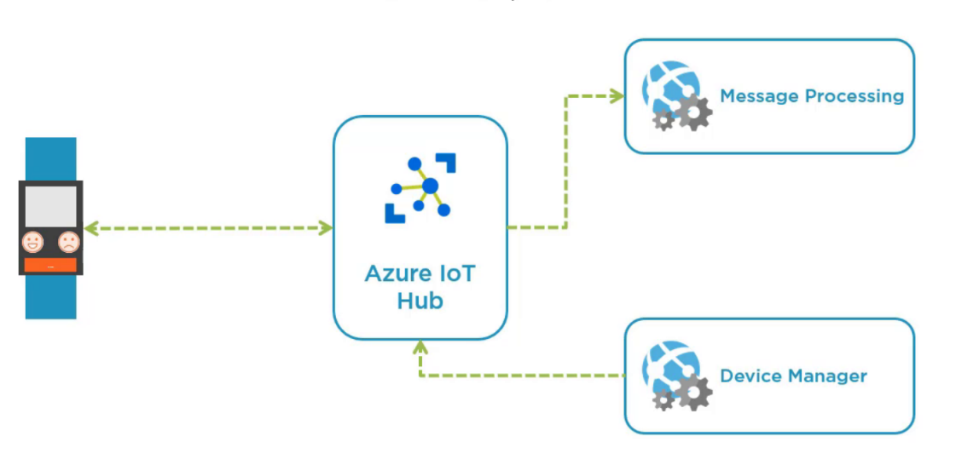

What to do?

Create Device Simulator that wait for message from Azure IoT Hub - back-end application

back-end

application

Azure IoT Hub

device

Open Visual Studio / Create C# Console App .NET Core / Name = d2c

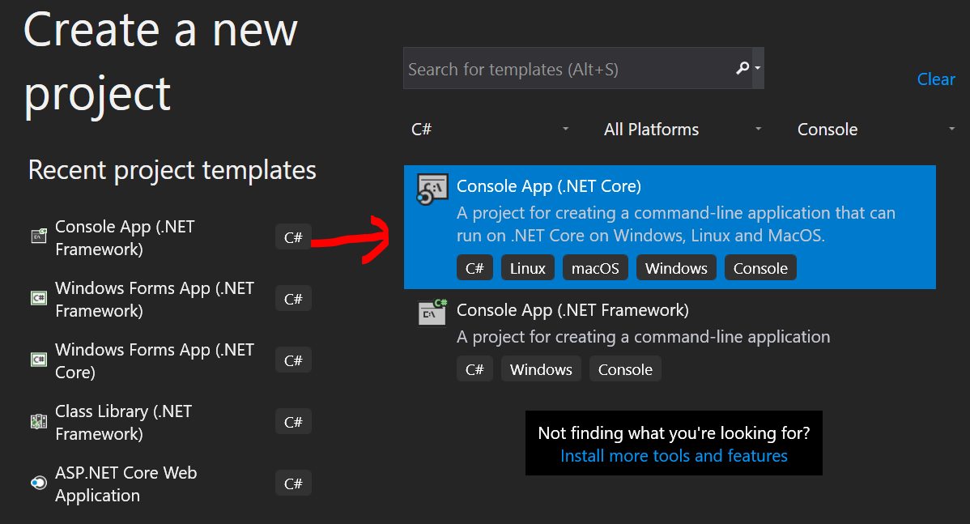

NuGet 2 packages

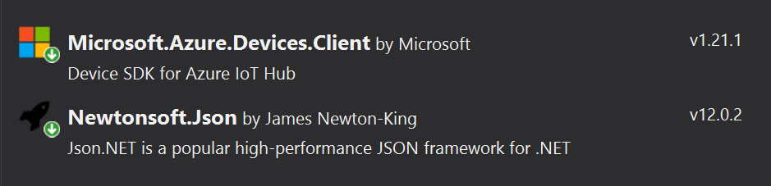

Add name space

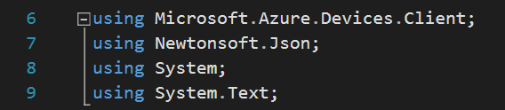

Add 2 Class fields



Add method ReciveC2dAsync

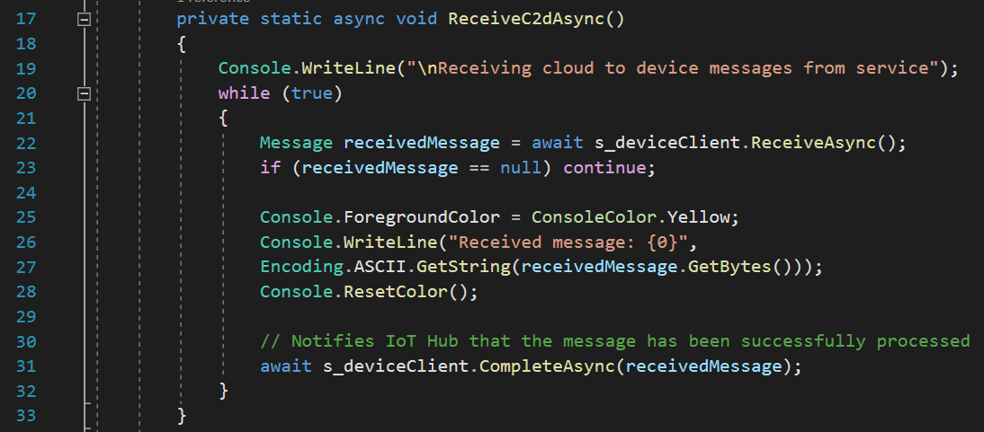

Add code to Main

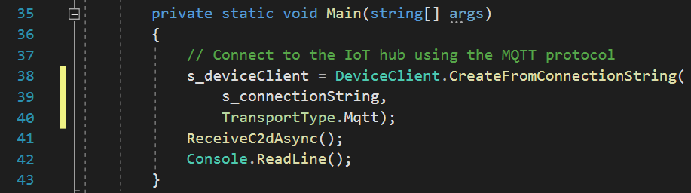

1. Run program to wait for message from cloud
2. Device Explorer / Messages to device / Send

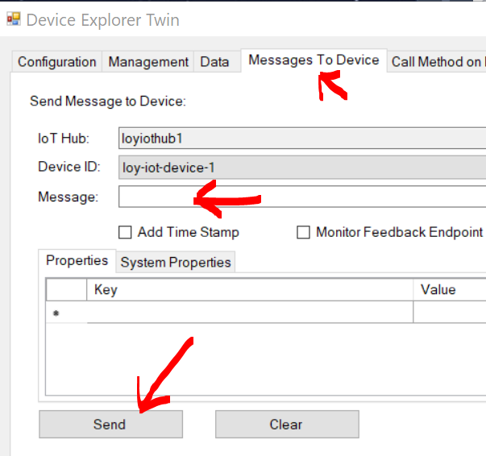

What's next?

